BECCS – ask danny or Candelaria

Harmonization potential parameters

Questions to Candelaria: -waiting for an answer

1. How BECCS is implemented in GCAM?
2. Which regions are used? What are the dimensions?
3. Parameters – analogy in GCAM for this parameters?

Questions for ReEDS: - sent answer to Laura

1. What are the capex and opex for carbon capture?
2. How these prices vary by region if they vary?
3. Scaling of BECCS facilities?
4. How storage price per ton of CO2 depends on size of the facility?
5. How to do calculation of the necessary Carbon storage facility?
6. How flexible to expanding the final size of the facility?

Questions for me to answer:

1. Carbon density and intensity used in the model?
2. How to incorporate BECCS additional co-product stream of income?
3. How to incorporate the carbon price?

Maybe the structure will be consisting of two streams: CO2 line of revenue, BECCS line of revenue or the same for costs.

How the investment decision will be affected by implementing BECCS in each model? Would it be more beneficial to build a BSM facility with or without BECCS? If a BSM is small and BECCS is not feasible to implement, how you should combine small BSM facilities that it is beneficial? How CO2 capture can be implemented in all modules even where there is no defined product stream but coproduct credit instead of stream?

Stages of BECCS:

1. Adding a new plant calculation

What should I do now:

1. Look through ReEDS website - yes
2. Text to a guy from ReEDS about BECCS - yes
3. Text Candelaria – yes
4. Check Carbon Density and intensity – waiting from Emily the access to LCFS
5. Dig into CHC and CE modules and comparison module in oil
6. In CHC and CE modules find coproduct streams and think about implementation of BECCS
7. Look at one not CHC, CE module with carbon credit logic and think how BECCS can be implemented there

Message from Steve

Irina,

I think that you’ll want to look at the OI module, where we appear to have logic around carbon taxes.  Then,  in the conversion modules, we’ll want to look at where we have coproducts explicitly represented in CHC and CE modules but I don’t think in any other modules.  In other modules we simply have a coproduct credit…not sure which approach makes the most sense here.

Finally, there is some feedback in the model from oil industry to production costs for agriculture, and I think we’d want to include carbon pricing in that—but I’m not sure we have it in the model.

This enough to get you going?

--steve

**Module: Feedstock Market**

**Comparison Against Baseline**

Reason: Possibility to use GCAM results instead of USDA to compare two models

1. What parameters we should input from GCAM into this module:
2. Raw Prodn Input from Baseline. Units: million USDA per Years.

What is it million USDA? Acres?

1. Raw Price Input From Baseline. Units: USD per unit.
2. Raw inventory input from baseline. Units: million usda.
3. What parameters to track:
4. A prodn model rel to USDA. Units: unitless. In our case instead of USDA, it should be GCAM.
5. A price model rel to USDA. Units: unitless.

Instead of USDA we use GCAM data.

1. Inventory rel to input. Units: unitless.
2. Rollup prodn payoff metric. Units: unitless. Basically, it is a sq error.
3. Rollup price payoff metric. Units: unitless.
4. Rollup inv payoff metric. Units: unitless.

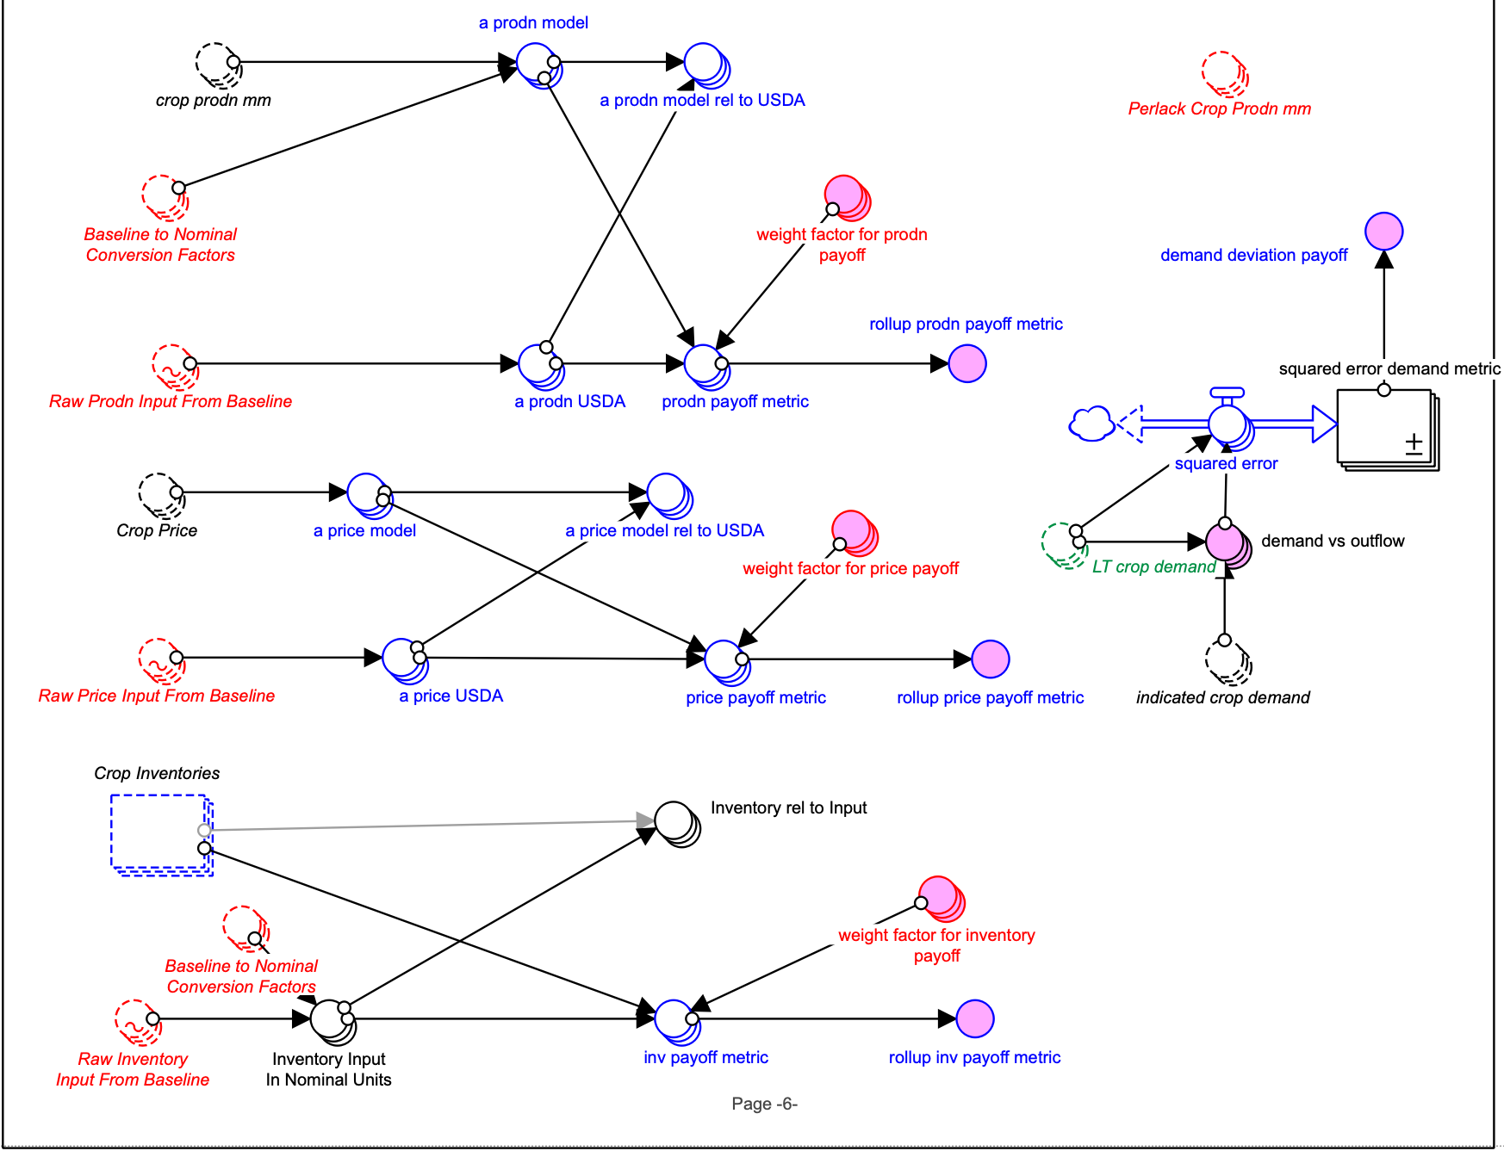

**II.6**

**II.5**

**II.4**

**II.3**

**II.2**

**II.1**

**I.3**

**I.2**

**I.1**

Question:

1. How we can modify Baseline to Nominal Conversion Factors? Units: USDA to nominal

**Module: Cellulosic to Ethanol**

Plant Financial and Operational and Scale factors and Logit input

1. BECCS FCI   
   Units: USD

Dimension: CtoATech,

1. BECCS FCI scale factor (Use the same scale factor as FCI scale factor or a new one?)

Units: unitless

Dimension: CtoATech

1. Next Plant BECCS FCI (either sum with NextPlant Expected FCI or separate converter?)

Units: USD

Dimension: CtoATEch, region

1. Expected BECCS Op Cost

Units: USD per Year

Dimension: CtoATech

1. BECCS Op Cost Scale factor (incorporate into scale factor used for fixed and expected other op cost or create another converter)

Units: unitless

Dimension: CtoATech

1. Next Plant Expected BECCS Op Cost (sum it with NextPlant Expected Other VBL Op cost or separate converter?)

Units: unitless

Dimension: CtoATech, region

1. Exp Other BECCS Sales Rev

Units: USD per Year

Dimension: CtoATech

1. BECCS Revenue scale (use existing one scaling factor or a new one)
2. Next Plant BECCS Sales Rev (separate or it is included in NextPlant other Coproduct sales rev?)

Units: USD per Year

Dimension: CtoATech, region

1. NextPlan ORNOVOC (other revenue (coproduct, BECCS, power) net of variable operating cost)- add Next Plant BECCS Sales Rev

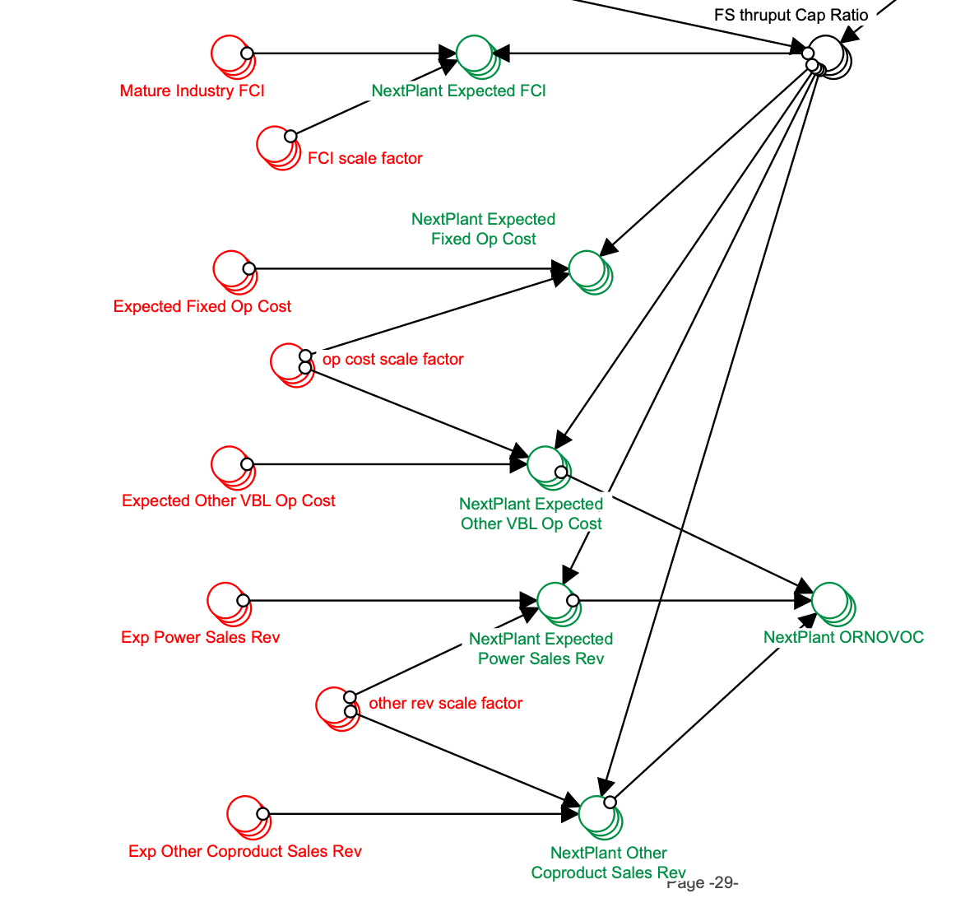

1. Next Plant Expected BECCS Op Cost (sum it with NextPlant Expected Other VBL Op cost or separate converter?)

Units: unitless

Dimension: CtoATech, region

1. Take scale factor from 2018 ReEDS report?

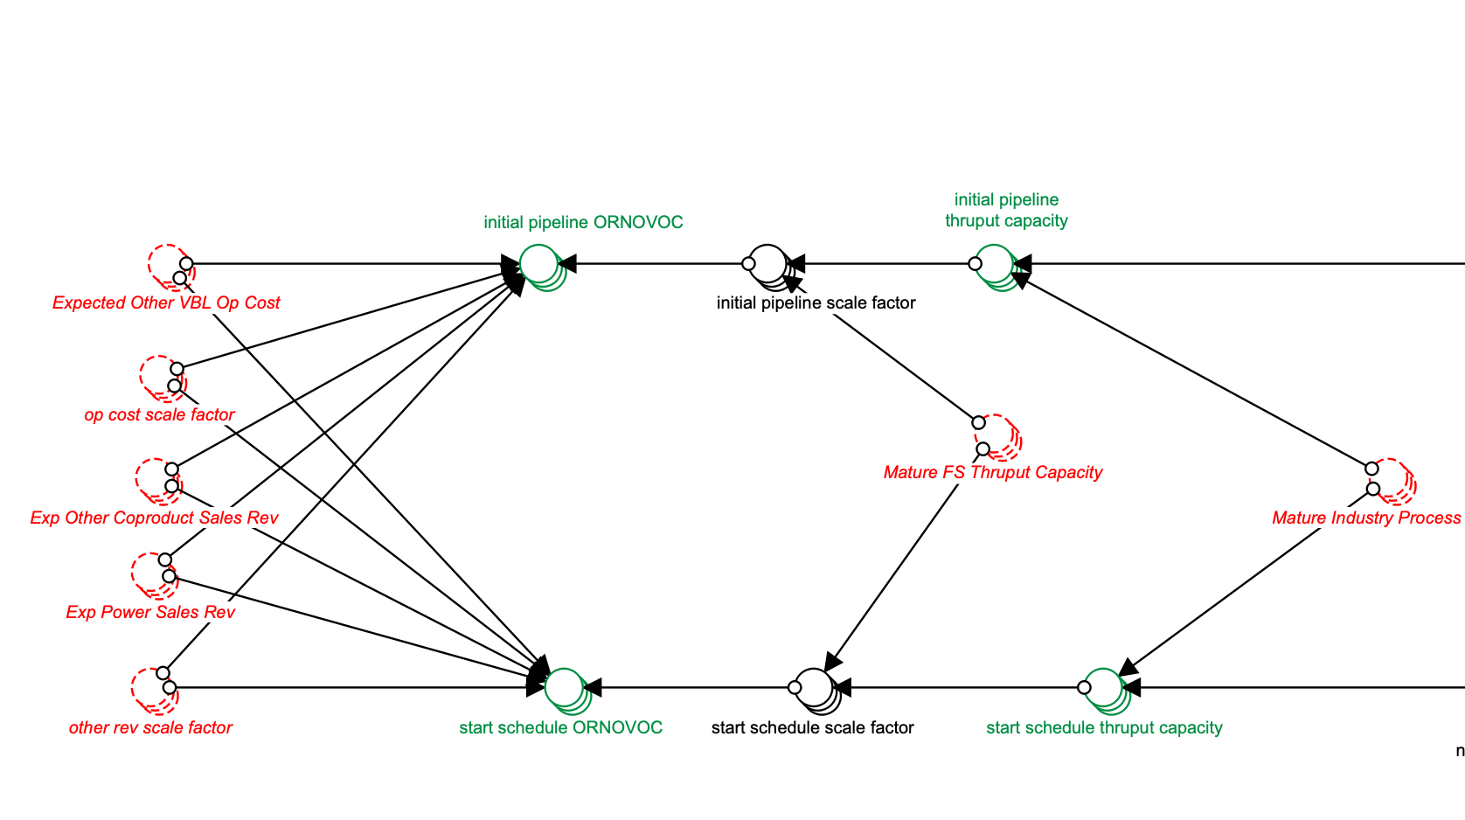

1. Next Plant BECCS Sales Rev (separate or it is included in NextPlant other Coproduct sales rev?)

Units: USD per Year

Dimension: CtoATech, region

1. Revenue scale factor for BECCS- use the same as here or not?

**MFSP and Utilization**

1. Next Plant BECCS Sales Rev (if it is nor in coproduct)

Units: USD per Year

Dimension: CtoATech, region

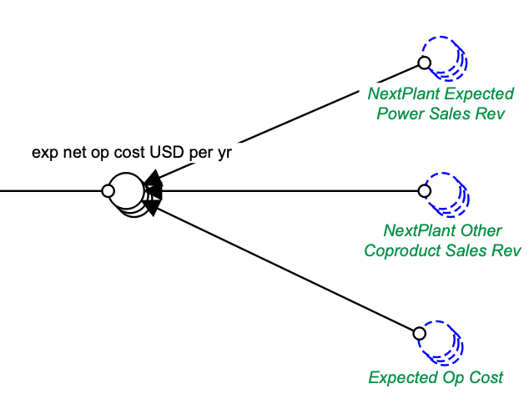

**Pro Forma Financials and NPV and Attractiveness**

1. Next Plant Expected BECCS Op Cost

Units: unitless

Dimension: CtoATech, region

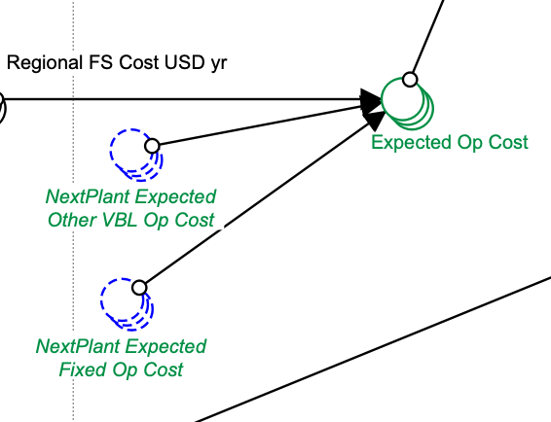

1. Next Plant BECCS Sales Rev

Units: USD per Year

Dimension: CtoATech, region

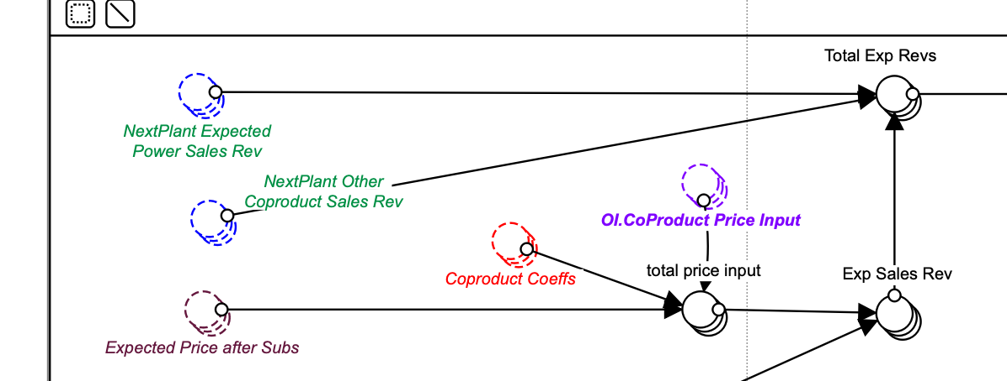

1. Next Plant BECCS FCI

Units: USD

Dimension: CtoATEch, region

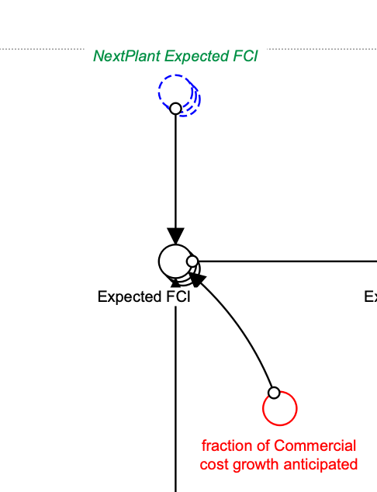

**GOVT POLICIES LOGIC**

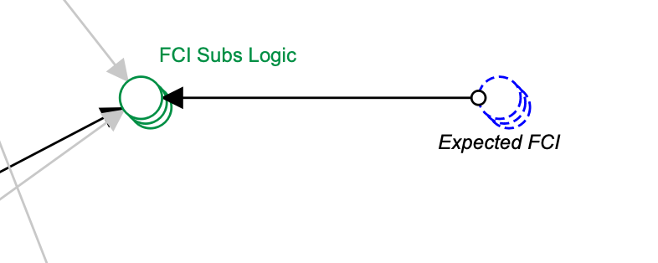

1. We can add expected BECCS FCI?

Units: USD

Dimension: CtoAtech, region

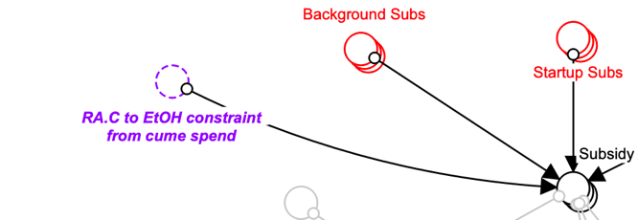

1. Maybe add BECCS subs here if there is any?

Units: unitless

Dimension: ConversionPolicy

**Module: Cellulosic to Hydrocarbon**

**Plant Financial and Operational and Scale factors and Logit input**

BECCS

1. BECCS FCI   
   Units: USD

Dimension: CtoRRTech,

1. BECCS FCI scale factor (Use the same scale factor as FCI scale factor or a new one?)

Units: unitless

Dimension: CtoRRTech

1. Next Plant BECCS FCI (either sum with NextPlant Expected FCI or separate converter?)

Units: USD

Dimension: CtoRRTEch, region

1. Expected BECCS Op Cost

Units: USD per Year

Dimension: CtoRRTech

1. BECCS Op Cost Scale factor (incorporate into scale facror used for fixed and expected other op cost or create another converter)

Units: unitless

Dimension: CtoRRTech

1. Next Plant Expected BECCS Op Cost(sum it with NextPlant Expected Other VBL Op cost or separate converter?)

Units: unitless

Dimension: CtoRRTech, region

1. Exp Other BECCS Sales Rev

Units: USD per Year

Dimension: CtoRRTech

1. BECCS Revenue scale (use existing one scaling factor or a new one)
2. Next Plant BECCS Sales Rev (separate or it is included in NextPlant other Coproduct sales rev?)

Units: USD per Year

Dimension: CtoRRTech, region

1. NextPlan ORNOVOC (other revenue (coproduct, BECCS, power) net of variable operating cost)- add Next Plant BECCS Sales Rev

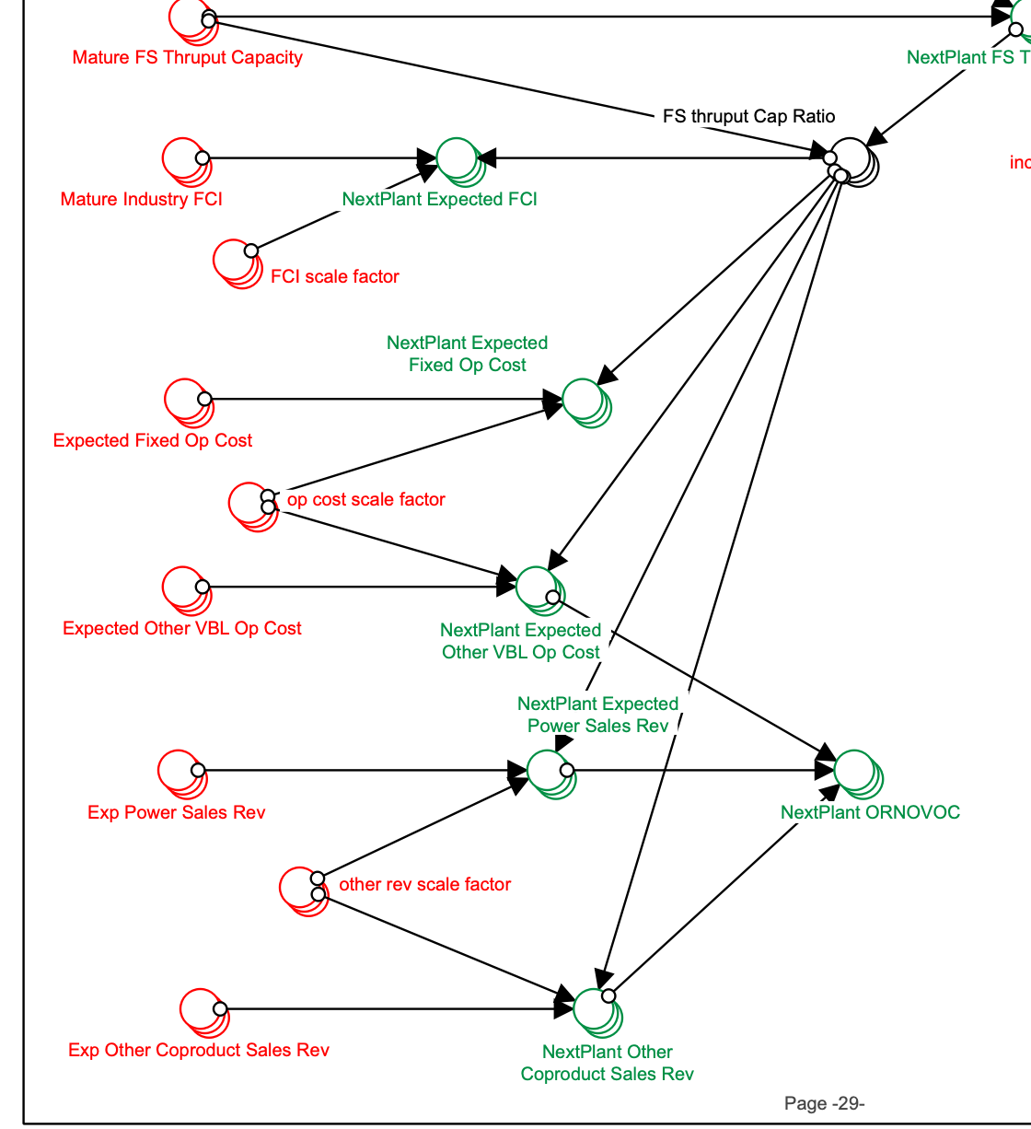

Do we need to include BECCS maturity in NextPlant FS Thruput Cap calculations?

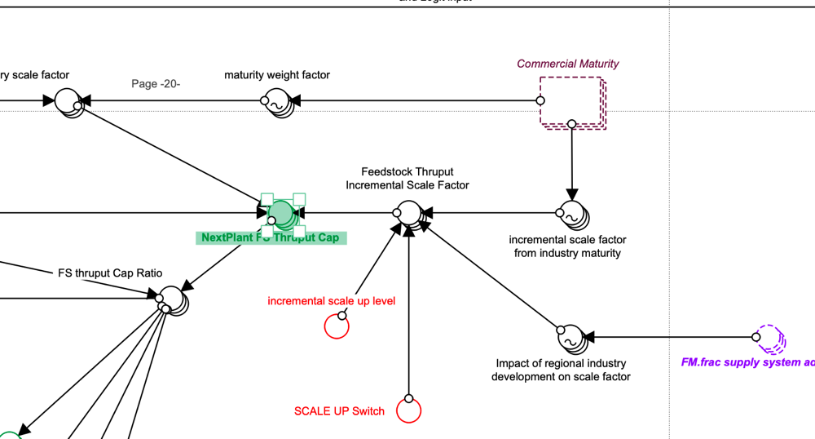

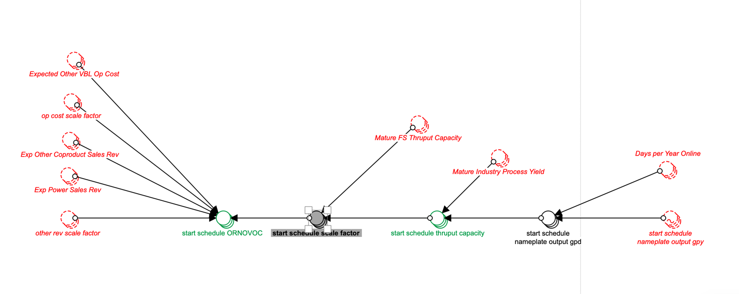

1. Expected BECCS Op Cost

Units: USD per Year

Dimension: CtoRRTech

1. BECCS Op Cost Scale factor (incorporate into scale facror used for fixed and expected other op cost or create another converter)

Units: unitless

Dimension: CtoRRTech

1. Next Plant BECCS Sales Rev (separate or it is included in NextPlant other Coproduct sales rev?)

Units: USD per Year

Dimension: CtoRRTech, region

1. Are we going to use other rev scale factor for BECCS rev?

**MFSP and Utilization**

1. Next Plant BECCS Sales Rev

Units: USD per Year

Dimension: CtoRRTech, region

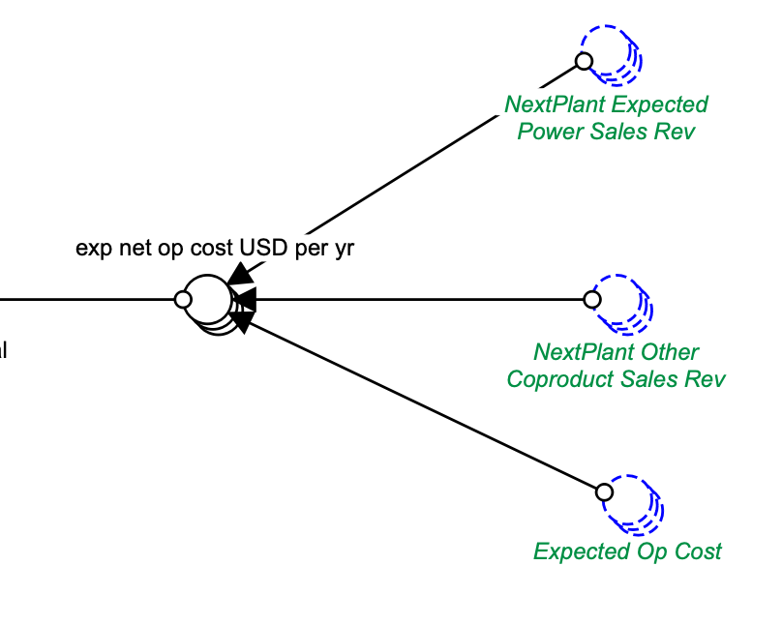

**Cumulative Govt Spend**

Is there any governmental sub if we implement BECCS?

**GOVT POLICIES LOGIC**

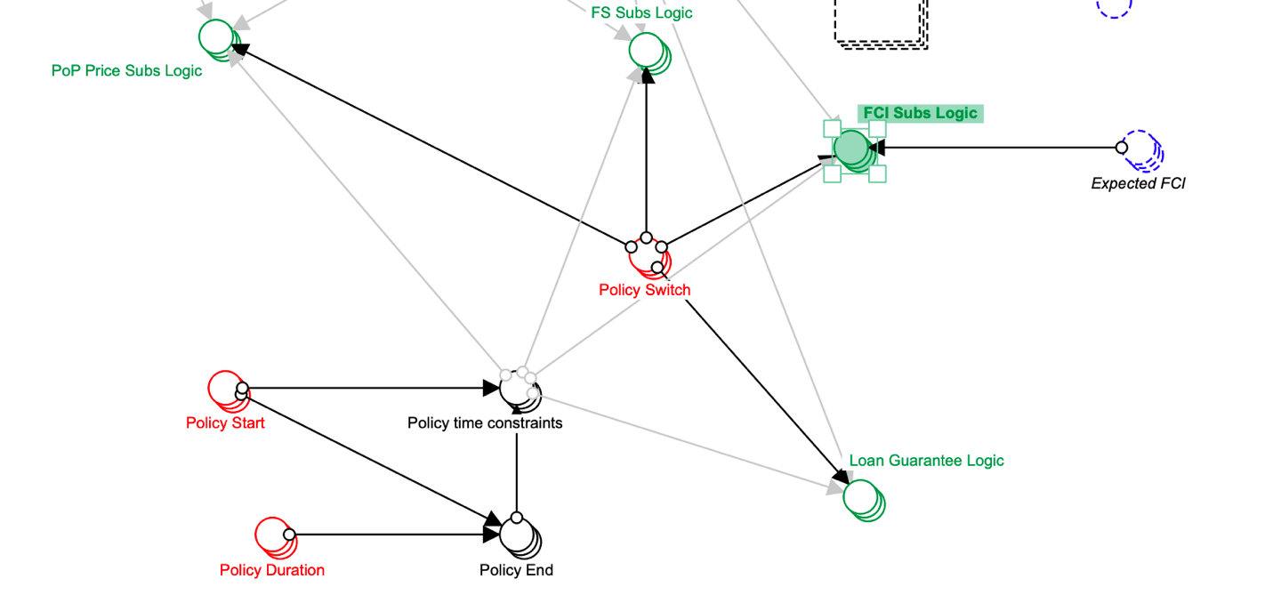

1. We can add expected BECCS FCI?

Units: USD

Dimension: CtoRRtech, region

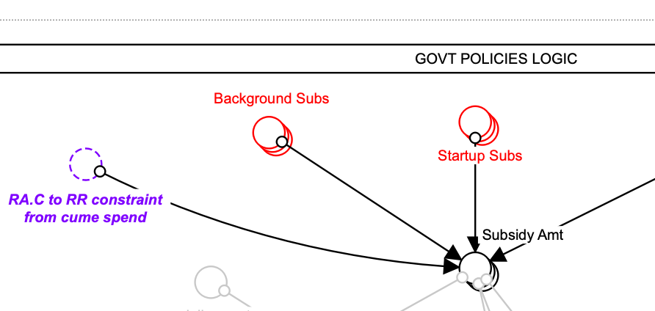

1. Maybe add BECCS subs here if there is any?

Units: unitless

Dimension: ConversionPolicy

﻿**Pro Forma Financials and NPV and Attractiveness** 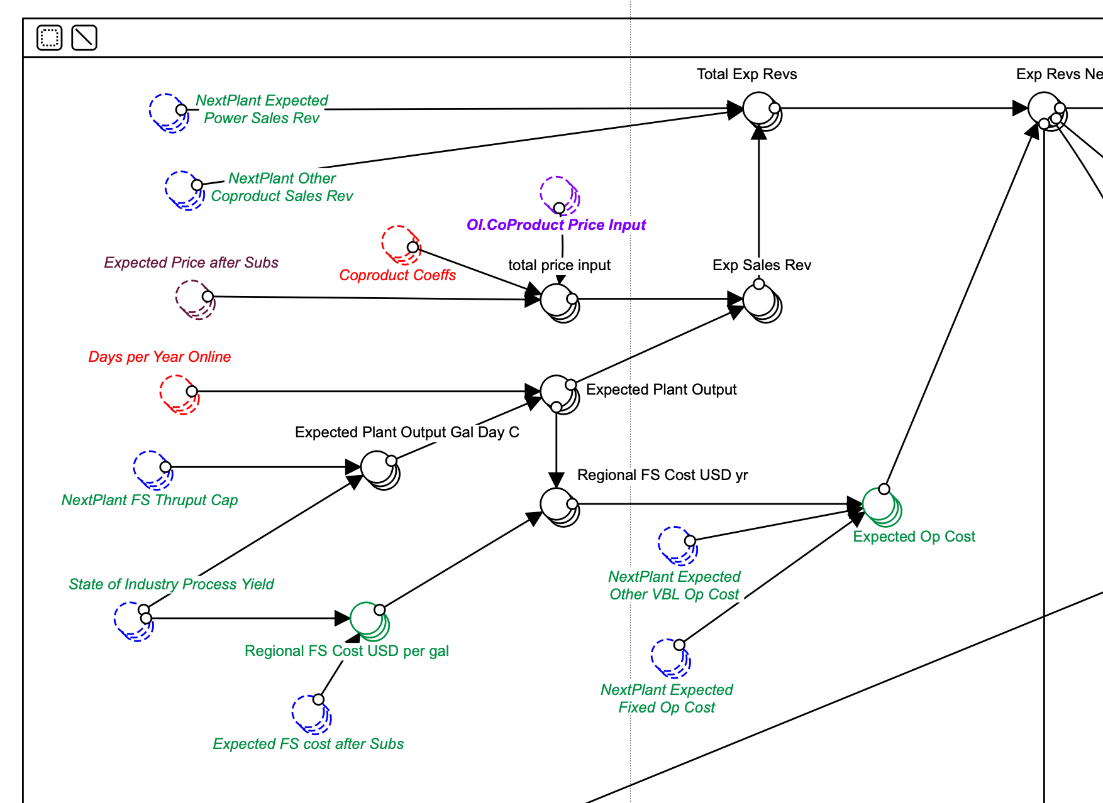

1. Next Plant BECCS Sales Rev

Units: USD per Year

Dimension: CtoRRTech, region

1. Next Plant Expected BECCS Op Cost

Units: unitless

Dimension: CtoRRTech, region

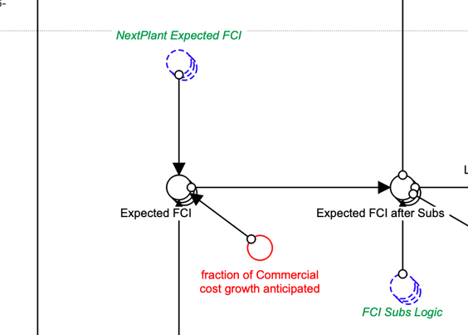

1. Next Plant BECCS FCI

Units: USD

Dimension: CtoRRTEch, region

﻿

Additional Question?

1. What do we know about BECCS maturity? (**Industry Development and Utilization and Learning Curves**)
2. Do we want to consider a separate loan for BECCS? (for example, for existing converting facilities. If yes, we would need to implement loan guarantee/ payment logic just for BECCS).

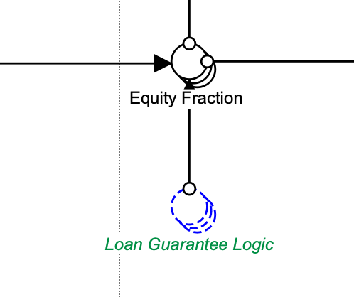

Screenshot from Pro Forma Financials and NPV and Attractiveness in CHC module

**Coal and gas CCS data**

From [Annual Technology Baseline](https://atb.nrel.gov/electricity/2019/data.html)

Gas – Combined Cycle with carbon capture sequestration

Base year – 2017$

Net Capacity factor:

Gas-CC-CCS-AvgCF = 51%,

Gas-CC-CCS-ConstantCF=87%

**Capex** ($/kW)= construction financing cost($/kW)+ overnight capital cost($/kW)

Capex ($/kW):

Gas-CC-CCS-AvgCF = 2,292$,

Gas-CC-CCS-ConstantCF=2,292$

Construction financing cost ($/kW):

Gas-CC-CCS-AvgCF = 50$,

Gas-CC-CCS-ConstantCF=50$

Overnight capital cost($/kW):

Gas-CC-CCS-AvgCF = 2,242$,

Gas-CC-CCS-ConstantCF=2,242$

Weighted Average Cost of Capital (WACC) (Nominal) (%)

Gas-CC-CCS-AvgCF = 5.3%,

Gas-CC-CCS-ConstantCF=5.3%

**Opex**

Fixed Operation and Maintenance Expenses ($/kW-yr):

Gas-CC-CCS-AvgCF = 34$

Gas-CC-CCS- ConstantCF = 34$

Variable Operation and Maintenance Expenses ($/MWh):

Gas-CC-CCS-AvgCF = 7$

Gas-CC-CCS- ConstantCF = 7$

Coal-Carbon capture sequestration-30%

Base year – 2017$

Net Capacity factor:

Coal-CCS 30%-AvgCF = 54%,

Coal-CCS 30%-ConstantCF=85%

**Capex** ($/kW)= construction financing cost($/kW)+ overnight capital cost($/kW)

Capex ($/kW):

Coal-CCS 30%-AvgCF = 5,633$,

Coal-CCS 30%-ConstantCF=5,633$

Construction financing cost ($/kW):

Coal-CCS 30%-AvgCF = 453$,

Coal-CCS 30%-ConstantCF=453$

Overnight capital cost($/kW):

Coal-CCS 30%-AvgCF = 5,180$,

Coal-CCS 30%-ConstantCF=5,180$

Weighted Average Cost of Capital (WACC) (Nominal) (%)

Coal-CCS 30%-AvgCF = 5.3%,

Coal-CCS 30%-ConstantCF=5.3%

**Opex**

Fixed Operation and Maintenance Expenses ($/kW-yr):

Coal-CCS 30%-AvgCF = 69$

Coal-CCS 30%-ConstantCF = 69$

Variable Operation and Maintenance Expenses ($/MWh):

Coal-CCS 30%-AvgCF = 7$

Coal-CCS 30%-ConstantCF = 7$

Coal-Carbon capture sequestration-90%

Base year – 2017$

Net Capacity factor:

Coal-CCS 90%-AvgCF = 54%,

Coal-CCS 90%-ConstantCF=85%

**Capex** ($/kW)= construction financing cost($/kW)+ overnight capital cost($/kW)

Capex ($/kW):

Coal-CCS 90%-AvgCF = 6,299$,

Coal-CCS 90%-ConstantCF=6,299$

Construction financing cost ($/kW):

Coal-CCS 90%-AvgCF = 501$,

Coal-CCS 90%-ConstantCF=501$

Overnight capital cost($/kW):

Coal-CCS 90%-AvgCF = 5,728$,

Coal-CCS 90%-ConstantCF=5,728$

Weighted Average Cost of Capital (WACC) (Nominal) (%)

Coal-CCS 90%-AvgCF = 5.3%,

Coal-CCS 90%-ConstantCF=5.3%

**Opex**

Fixed Operation and Maintenance Expenses ($/kW-yr):

Coal-CCS 90%-AvgCF = 80$

Coal-CCS 90%-ConstantCF = 80$

Variable Operation and Maintenance Expenses ($/MWh):

Coal-CCS 90%-AvgCF = 10$

Coal-CCS 90%-ConstantCF = 10$

Scaling factors can be adjusted from 2018 ReEDS documentation

